**Bronze whaler**

**Occurence**

Carcharhinus brachyurus is an essentially warm temperate and subtropical species (Garrick 1982, Compagno 1984, Muñoz-Chápuli 1984, Smale 1991, Cappo 1992, Cliff and Dudley 1992, Chiaramonte 1998). It is a widespread but patchily distributed coastal and shelf species, occasionally reported from oceanic areas close to the continental shelf (Amorim et al. 1998, Marín et al. 1998, Bagley et al. 2000). It readily enters shallow water, and individuals and aggregations are often sighted in shallow bays, the surf zone and in harbour channels during summer (Ayling and Cox 1982, Cappo 1992, Last and Stevens 1994). It also occurs in brackish or freshwater in the lower reaches of large rivers and estuarine bays (Last 2002). Maximum reported depth is 100 m but it is likely to range deeper (Compagno 1984, Smale 1991, Last and Stevens 1994).

In Australian waters C. brachyurus is infrequently recorded north of Sydney or Perth, being most abundant between Albany (Western Australia) and Bass Strait (Last and Stevens 1994, R. McAuley, pers. comm., C. Simpfendorfer, pers. comm., J. Stevens, pers. comm.).

**Diet**

Diet includes a wide variety of bottom-living and pelagic cephalopods and fishes including squid (Loligo spp.), cuttlefish, octopus, spiny dogfish (Squalus spp.), stingrays, electric rays, sawfish, gurnard, flatfish, hake, catfish, ling, jacks, kahawai/Australian salmon, mullet, sea bream, sardines and anchovy (Illingworth 1961, Compagno 1984, Comapgno et al. 1989, Smale 1991, Cliff and Dudley 1992, Last and Stevens 1994, Francis 2001). Juveniles also feed on jellyfishes (Scyphozoa) and benthic crustacea (Callianasa spp. and Penaeid shrimps) (Smale 1991). Other elasmobranchs are taken with greatest frequency by sharks over 2 m total length (Smale 1991, Cliff and Dudley 1992).

**Hammerhead**

different species of fish, small sharks and rays. However, spineless fish such as crawfish, squid and other similar fish have also been found in analyses of stomach contents. This species is also known to eat carrion.

Juvenile *S. lewini* consumed a mixture of crustacean and teleost prey. Crustaceans were more important than teleosts according to number (60.77%), frequency of occurrence (99.68%), and IRI (62.08%). Teleosts were more important by weight (47.83% vs. 25.83% for crustaceans). *Alpheus malabaricus* appears to account for ca. 36% of the diet (IRI). Only a single specimen was identified

as another species of alpheid. Teleosts composed ca. 47% of the diet (IRI), and consisted of at least ten species from nine families. Gobies were the most important teleost group and consisted of two

identifiable species, *Oxyuricthys lonchotus* and *Hazeus nephodes*. The remaining 17% of the diet was composed of a variety of crabs, stomatopods, unidentifiable and undigestible material (Table 1). (Bush 2003)

The diet of other hammerhead sharks is dominated by fish (Clarke, 1971; Compagno, 1984, 1988; Wetherbee et al., 1990; Stevens and Lyle, 1989; Strong et al., 1990).

**White tip** *Carcharhinus longimanus*

**Occurence**

This is one of the most widespread sharks, ranging across entire oceans in tropical and subtropical waters. The oceanic whitetip is an oceanic-epipelagic shark, usually found far offshore in the open sea in waters >200 m deep.

**diet**

This pelagic species feeds mainly on bony fishes (including tunas, barracuda, white marlin, dolphinfish, lancetfish, oarfish, threadfish, swordfish) and cephalopods and to a lesser extent, seabirds, marine mammals, stingrays, and flotsam, including garbage.

**Blue shark** *Prionace glauca*

It is oceanic and pelagic, found from the surface to about 350 m depth; occasionally it occurs close inshore where the continental shelf is narrow. The Blue Shark prefers temperatures of 12'20°C and is found at greater depths in tropical waters (Last and Stevens 1994).

The diet of Blue Sharks consists mainly of small pelagic fish and cephalopods, particularly squid; however, invertebrates (mainly pelagic crustaceans), small sharks, cetaceans (possibly carrion) and seabirds are also taken (Compagno 1984b). While most of the fish prey is pelagic, bottom fishes also feature in the diet.

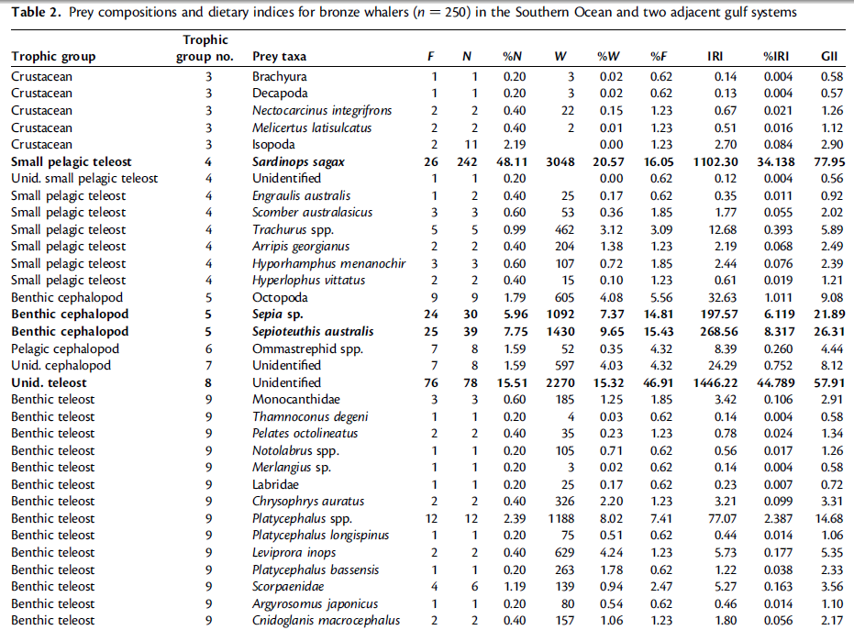

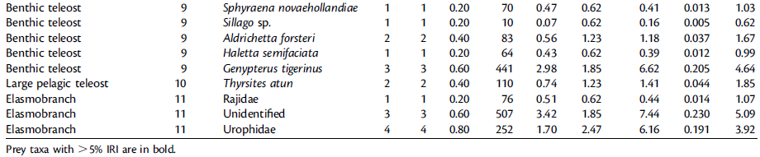

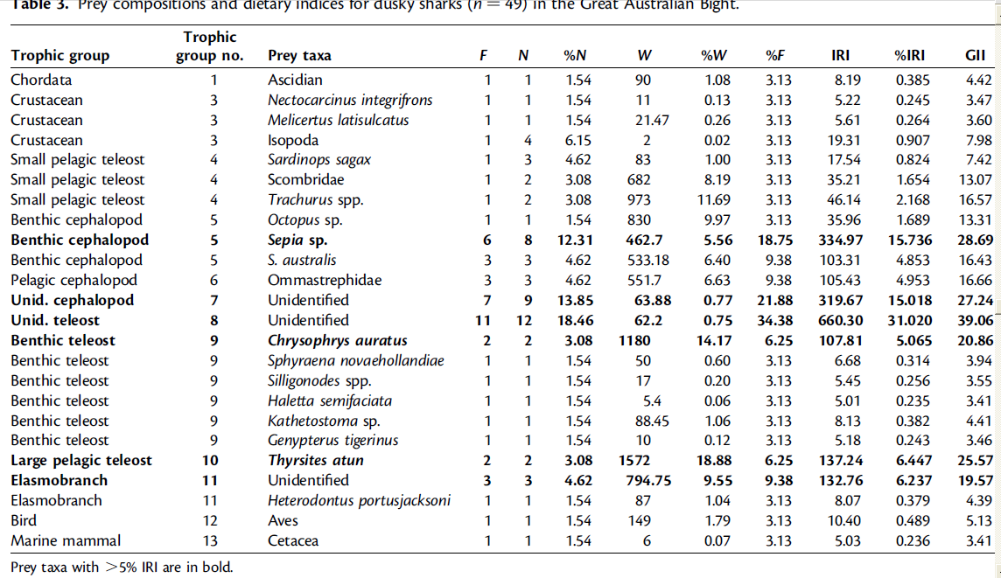

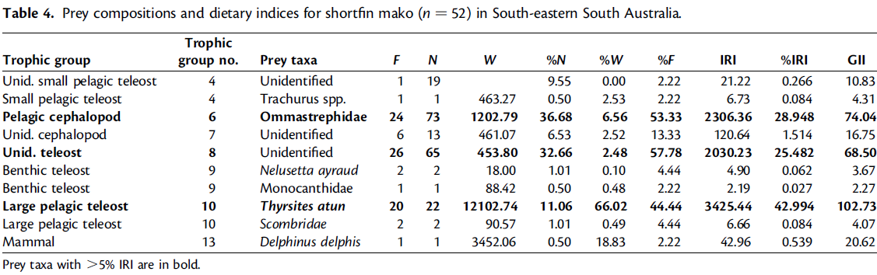

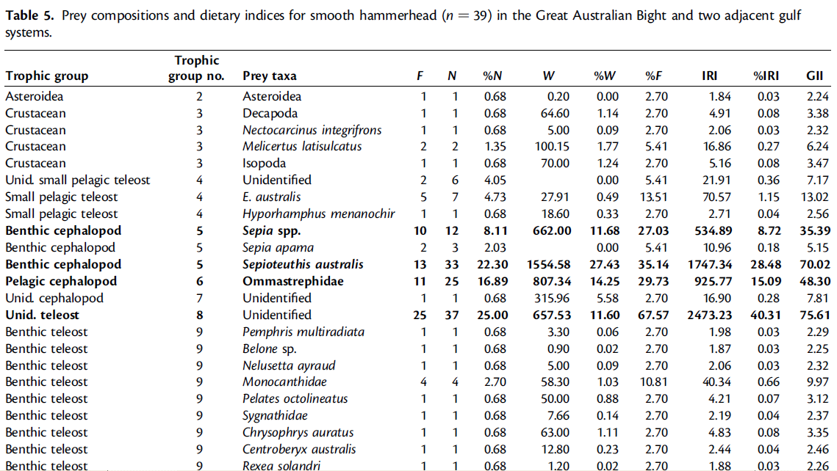



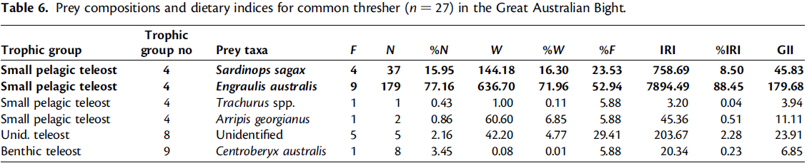

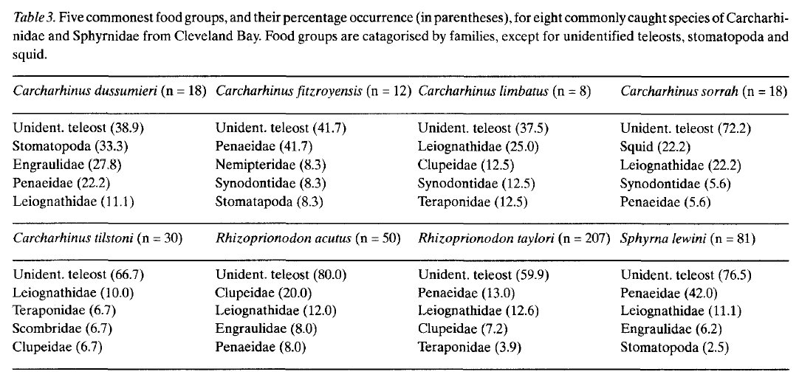

The main families of prey items found in the stomachs of the eight commonly occurring species appeared similar (Table 3). Teleosts were the most common food of all eight species examined, with species of the families Leiognathidae, Clupeidae, Engraulidae and Synodontidae the commonest (after unidentified teleosts). Crustaceans, especially of the Penaeidae, were amongst the five most common food groups in all species, except C. limbatus and C. tilstoni. Crustaceans were particularly common in the stomach contents of the C. dussumieri, C. fitzroyensis and S. lewini specimens examined. Squid only occurred in the five commonest food groups in one species, C. sorruh.

**Pelagic shark adult:**

|  |  |
| --- | --- |
| **prey item** | **probability of consuming** |
| rays (RAY) | 0.1 |
| Southern bluefin Tuna (BLT) | 0.3 |
| dolphin (DOL) | 0.1 |
| dhufish (dhu) | 0.2 |
| seabird (SB) | 0.05 |
| migratory piscivores (FPI) | 0.1 |
| pelagic piscivores (FPP) | 0.2 |
| pelagic planktivores (FPK) | 0.2 |
| demersal shallow carnivore (FDC) | 0.2 |
| Demersal shallow omnivore (FDO) | 0.2 |
| deep demersal fish (FDD) | 0.1 |
| Pink_Snapper (PKS) | 0.2 |
| Sardines (SAR) | 0.3 |
| Demersal macroalgal feeders (FMA) | 0.1 |
| Large Shallow piscivores (FSP) | 0.2 |
| Large reef associated (FLR) | 0.2 |
| Cephalopod CEP | 0.3 |
| Carion (DC) | 0.3 |

**Pelagic shark juvenile:**

|  |  |
| --- | --- |
| **prey item** | **probability of consuming** |
| Small reef associated (FSR) | 0.1 |
| Small reef associated (FSR) | 0.1 |
| demersal shallow carnivore (FDC) | 0.1 |
| Macrobenthos MAZ | 0.1 |
| Swimming Decapods ZKL | 0.1 |
| Prawns (PRW) | 0.2 |
| Carion (DC) | 0.2 |

Reference

Rogers, P.J., Huveneers, C., Page, B., Hamer, D. J., Goldsworthy, S. D., Mitchell, J. G., and Seuront, L. A 2012. Quantitative comparison of the diets of sympatric pelagic sharks in gulf and shelf ecosystems off southern Australia – ICES Journal of Marine Science. doi:10.1093/icesjms/fss100

Colin A. Simpfendorfer & Norman E. Milward 1993 Utilisation of a tropical bay as a nursery area by sharks of the families Carcharhinidae and Sphyrnidae Environmental Biology of Fishes 37: 33T345,1993